**ADTA 5770.501: Midterm Assessment PART III**

**Student: Yog Chaudhary**

**4.1 Question 1: The Transformer – An Overview (5 Points)**

Write an essay:

* To present an overview of the Transformer neural network.
* The overview should include some history of its advent, general information about its AI-related technology and its applications

The Transformer neural network is a foundational architecture within the realm of artificial intelligence, particularly in the field of natural language processing.

In the seminal 2017 paper, Vaswani et al. introduced the Transformer architecture, revolutionizing AI language processing by surpassing RNNs and LSTMs in efficiency and effectiveness.

Historical Background:

RNNs and LSTMs processed sequences step-by-step but struggled with vanishing gradients and long-range dependencies, leading to the Transformer’s development.

General Information, and applications about the Transformer:

The Transformer model has an encoder-decoder structure, but modern versions like BERT and GPT adjust it for specific tasks. The encoder reads the input and creates a representation, while the decoder uses this information and past outputs to generate the final result. A key feature of the Transformer is its self-attention mechanism in both the encoder and decoder. This helps the model focus on important parts of the input when making predictions, improving context understanding. Since Transformers don’t process data step by step like RNNs, they use positional encodings to remember the order of information

The Transformer has an impact on various AI applications, primarily due to its ability to understand and generate human language with high accuracy. Here are some notable applications:

* Machine Translation
* Text Summarization
* Sentiment Analysis
* chatbots and Conversational AI
* Language Understanding and Question Answering

In conclusion, the Transformer network has become a cornerstone of modern NLP due to its efficiency, scalability, and capability to manage complex language tasks. Its revolutionary approach to handling sequences through attention mechanisms has paved the way for a multitude of AI applications, influencing both research and practical implementations across industries. As technology continues to evolve, its impact on AI and our interaction with machines is poised to grow even further.

**4.2 Question 2: The Transformer – The Neural Network Architecture (10 Points)**

Write an essay:

* To present an overview of the architecture of the Transformer neural network.
* To describe in detail each operational block of the architecture, including how each block works
* To provide a complete, simple example – end to end: from inputs to outputs – to demonstrate the overall operation process of the Transformer, including the role of each block of the architecture.

Transformer architecture has revolutionized natural language processing due to its ability to handle long-range dependencies in sequences. RNNs and LSTMs, which process sequence data word by word, Transformers use a mechanism called self-attention to process the entire input sequence simultaneously, making them highly efficient for tasks like language translation, text summarization, and question answering. The following transformer model is based on an encoder-decoder structure.

1. **Attention mechanism**

The attention mechanism allows the model to focus on different parts of the input sequence when processing a particular element, much like how humans pay attention to specific words or phrases when understanding a sentence. For example, if you have a question (query) about a specific word in a sentence. To find the answer, you search for relevant information (keys) in other parts of the sentence. The information itself is the value.

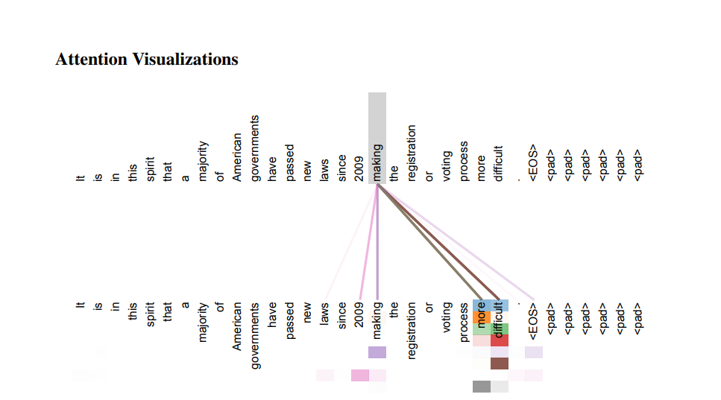

**Calculate Attention Scores:** For each word in the sequence, the model computes attention scores with every other word. These scores reflect the relevance of each word to the query word. The higher the score, the more important the key is for understanding the query

**Normalize Scores:** The attention scores are normalized using a SoftMax function, producing a probability distribution where the weights sum up to 1, ensuring that the model focuses on the most relevant words.

1. **Multi-head attention:**

Attention mechanism is powerful, transformers use multi-head attention to capture a broader range of relationships within the input sequence, akin to having multiple sets of eyes, each focusing on different aspects of the sentence.

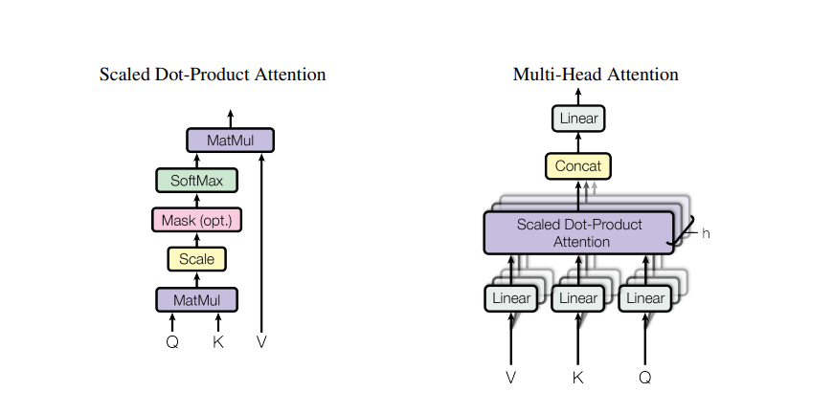

1. **Position encoding:**

RNNs has process sequences sequentially, transformers process the entire sequence in parallel, significantly boosting efficiency but posing a challenge, preserving the order of words, which is crucial for understanding language.

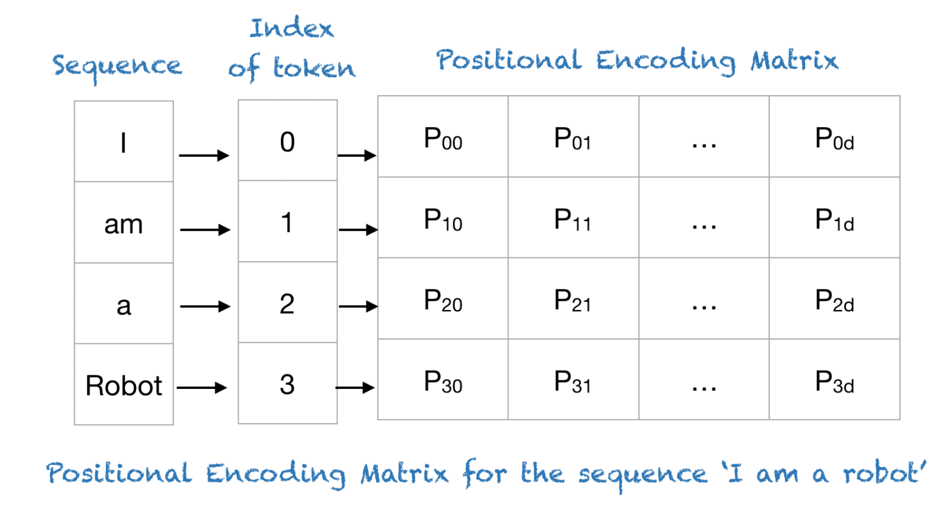

These encodings can be generated using different methods, such as sinusoidal functions or learned embeddings. The key is to provide the model with information about the word's position, allowing it to understand the sequence's structure despite processing it in parallel.

1. **Feed-forward network:**

The output is passed through feed-forward networks after the attention mechanism has identified and aggregated relevant information. These networks are fully connected layers that apply non-linear transformations to the attention output, further refining the representation of each word. They can be considered filters that extract higher-level features and patterns from contextualized information.

1. **The encoder-decoder structure:**

A transformer model follows an encoder-decoder structure.



**Encoder:** The encoder takes the input sequence and transforms it into a rich, contextualized representation. It achieves this through a series of identical layers, each performing an important role in understanding the input.

**Decoder:** The decoder generates the output sequence. It also consists of stacked layers, mirroring the encoder's structure. However, the decoder incorporates additional mechanisms to ensure the output is generated sequentially and coherently

* Layer Normalization.
* Residual Connections.
* Final Linear Layer and SoftMax : Transform the decoder's output into logits (raw predictions) and further into a probability distribution over the vocabulary.



**End-to-End for Example**

Consider the task of English-to-French translation using a Transformer model.

* Input: The sentence "Transformers are powerful. is first tokenized and converted into embeddings.
* Positional Encoding: Positional information is added to these embeddings, which is necessary for capturing the order of words.

**Encoding Process:**

* The sentence is fed into the encoder where each word interacts with every other word to produce a context-rich representation.
* The self-attention mechanism helps identify words like powerful as crucial in understanding the sentence's intent.

**Decoding Process:**

* The decoder generates the French output word by word. For the first position, it uses a start token to predict the next word.
* The encoder-decoder attention mechanism helps the decoder align to relevant parts of the input sentence.
* **Output:** Finally, it outputs a probability distribution over the French vocabulary for each position. For instance, it might output "Les transformers sent puissant."

In conclusion, in each decoding step, the generated word is fed back into the decoder as input for predicting the subsequent word. The overall efficiency and translation quality stem from the ability of each word in the sentence to attend globally over all other words through self-attention, enabling the model to capture significant patterns and dependencies across the entire input sequence.

**4.3 Question 3: The Transformer – A Revolutionary Achievement in AI NLP (15 Points)**

Write an essay:

* To present the revolutionary features of the Transformer’s architecture that made it a disruptive technology leap in the NLP field.
* To discuss in detail how Transformer-based LLMs like OpenAI’s GPT, Anthropic’s Claude, or Alphabet/Google’s Gemini can have significant impacts on human life with respect to the student’s selected domain expertise field.

Transformer architecture has brought a major change in Natural Language Processing (NLP). Introduced by Vaswani, it replaced the step-by-step processing of traditional Recurrent Neural Networks (RNNs) with an attention-based method. Its powerful features have made it a leading model in NLP, greatly improving language understanding and text generation.

**Revolutionary Features of the Transformer as following.**

1. **Multiple-Attention Mechanism:** The Transformer's architecture is the self-attention mechanism, which allows the model to weigh the importance of different words in a sentence regardless of their position. This mechanism computes a set of attention scores for each word with respect to all other words, capturing long-range dependencies and contextual relationships effectively. As a result, the Transformer can process information in a sentence holistically, providing a more nuanced understanding of context compared to RNNs, which are limited by their sequential nature.



1. **Parallelization and Efficiency:** One of the key advantages of the Transformer is its ability to process data in parallel, as opposed to the sequential processing of RNNs. This is possible because the self-attention mechanism does not rely on previous time step outputs to make current predictions. Consequently, the Transformer can leverage modern computational resources more efficiently, leading to significant reductions in training time and enabling the processing of larger datasets.



1. **Positional Encoding:** RNNs, which inherently consider the order of words due to their sequential processing, the Transformer requires a mechanism to inject word order information into its model. This is accomplished using positional encoding, where unique vectors are added to the input embeddings to provide information about the position of each word. This allows the Transformer to retain the knowledge of sequence information, despite its parallel architecture.



1. **Layer Normalization and Residual Connections:** To maintain the stability and effectiveness of training deep networks, the Transformer incorporates layer normalization and residual connections. Layer normalization helps in stabilizing the training process, while residual connections enable better gradient flow through the network, addressing common issues like vanishing gradients seen in traditional deep learning architectures.
2. **Facilitation of Transfer Learning:** The Transformer has paved the way for significant breakthroughs in transfer learning in NLP. Models like BERT and GPT are built on the Transformer architecture and have set new benchmarks by pre-training vast amounts of text and fine-tuning on specific tasks. This approach enables the model to leverage previously learned features, improving performance with less labeled data.

In Conclusion, The Transformer architecture has been a revolutionary achievement in the field of NLP. By shifting from a sequential to a parallel processing leveraging the self-attention mechanism, the Transformer not only overcomes the limitations of previous models but also sets the stage for innovative developments in artificial intelligence. Its flexibility continues to drive progress in language models, making it a central component in modern AI applications. The fundamental changes it brought to processing natural language not only reshaped current approaches but also laid the foundation for future innovations in the field.